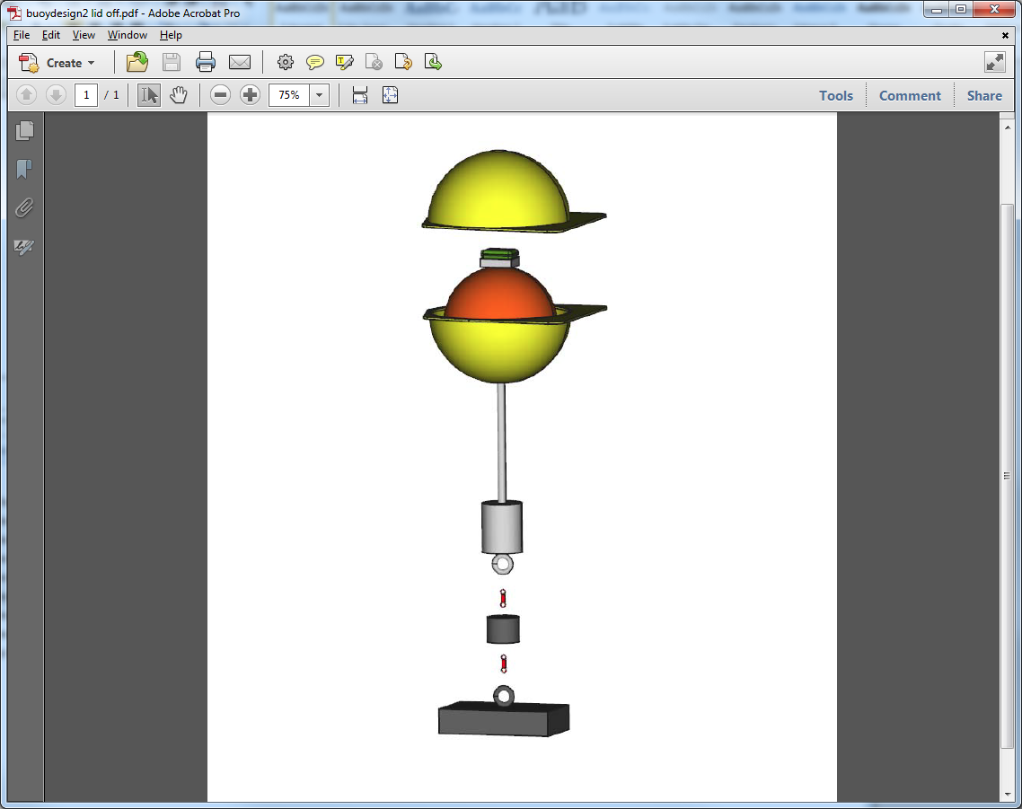

**Anchor:** Holds Buoy on Bottom during Initial Period

**4-Day Release:** Releases Buoy from Bottom

**10-lb Weight:** Allows for Slow Vertical Profile when Buoy Releases

**14-Day Release:** Drops Extra Weight for Better Data Transmission

**Counter-Weight:** Keeps Buoy Upright Under Ice

**Trawl Float:** Provides Flotation

**Hard Hat:** Provides Protection

**Satellite Tag:** Collects Data